LIGHT PROPERTIES W.S.

Refer to the following information for the next three questions:

The first investigation that led to a determination of the speed of light was performed in about 1675 by the Danish astronomer Olaus Roemer. He made careful measurements of the period of Io, a moon about the planet Jupiter, and was surprised to find an irregularity in Io's observed period. While the earth was moving away from Jupiter, the measured periods were slightly longer than average. While the earth approached Jupiter, they were shorter than average. Roemer estimated that the cumulative discrepancy amounted to about 16.5 minutes. Later interpretations showed that what occurs is that light takes about 16.5 minutes to travel the extra distance across the earth's orbit. Aha! We have enough information to calculate the speed of light

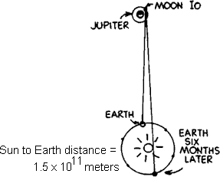
- What is the diameter, in meters, of the earth's orbit around the sun?

- According to Roemer, about how many seconds does it take light to travel across the diameter of the earth's orbit?

- How do these two quantities determine the speed of light?

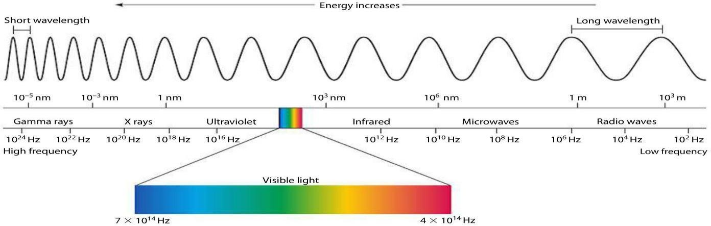
Refer to the following information for the next four questions.

Study a chart of the electromagnetic spectrum and answer the following questions.

- Which has the longer wavelengths, radio waves or waves of visible light?

radio waves | visible light

- Which has the longer wavelengths, waves of visible light or gamma rays?

visible light | gamma rays

- Which has the higher frequencies, ultraviolet or infrared waves?

ultraviolet waves | infrared waves

7. Which has the higher frequencies, ultraviolet waves or gamma rays?
ultraviolet waves gamma rays
Refer to the book for the following information for the next seven questions:
8. When ultraviolet light shines on glass, what does it do to electrons in the glass structure?

- When energetic electrons in the glass structure vibrate against neighboring atoms, what happens to the energy of vibration?

- What happens to the energy of a vibrating electron that does not collide with neighboring atoms?

- Light in which range of frequencies, visible or ultraviolet, is absorbed in glass?

visible | ultraviolet

- Light in which range of frequencies, visible or ultraviolet, is transmitted through glass?

visible | ultraviolet

- How is the speed of light in glass affected by the succession of time delays that accompany the absorption and re-emission of light from atom to atom in the glass?

- How does the speed of light compare in water, glass, and diamond?

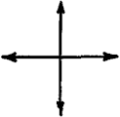
The amplitude of a light wave has magnitude and direction, and can be represented by a vector. Polarized light vibrates in a single direction and is represented by a single vector. To the left the single vector represents vertically polarized light. The vibrations of non-polarized light are equal in all directions. There are as many vertical components as horizontal components. The pair of perpendicular vectors to the right represents non-polarized light.

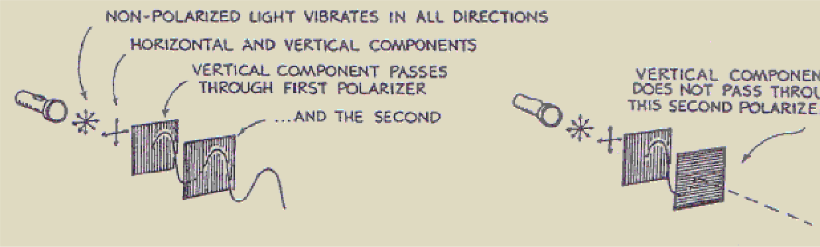
Refer to the following information for the next three questions.

In the sketch below non-polarized light from a flashlight strikes a pair of Polaroid filters.

- Light is transmitted by a pair of Polaroids when their axes are .

aligned | crossed at right angles

- Light is blocked when their axes are .

aligned | crossed at right angles

- Transmitted light is polarized in a direction the polarization axis of the filter.

the same as | different than
Refer to the following information for the next six questions.

18. Carefully count the number of wavelengths (same as the number of wave crests) along the following paths between the slits and the screen.
The number of wavelengths between slit A and point a equals

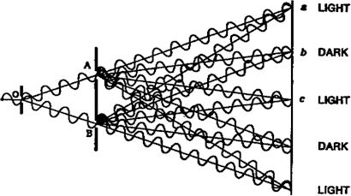
The number of wavelengths between slit B and point a equals

The number of wavelengths between slit A and point b equals
The number of wavelengths between slit B and point b equals

The number of wavelengths between slit A and point c equals

The number of wavelengths between slit B and point c equals

- When the number of wavelengths along each path is the same or differs by one or more whole wavelengths, interference is .

constructive | destructive

- When the number of wavelengths differ by a half wavelength or an odd multiple of a half wavelength, interference is .

constructive | destructive
- How do radio waves differ from microwaves and X-rays?

- Why do people usually get darker or tanner when continually exposed to sunlight?
- When you are sunbathing and the sun “goes behind a cloud,” it feels cooler. It is also common to get a sunburn on a cloudy, cool day. Explain these experiences in term of types of electromagnetic waves. (Hint: Consider absorption and transmission in the “greenhouse” effect.)

- How do “sunscreens” in suntan oils and lotions prevent sunburns?

- In movies and actual practice, money is sometimes “marked” and messages are written with substances that can be seen only under ultraviolet light. Why is ultraviolet so special?

- Mercury-vapor street lights have a bluish hue, while the newer sodium arc lamps have a yellow appearance. Explain this difference.

- At a disco, the black light over the band blows out and there are no more bulbs available. The proprietor decides to use an infrared lamp instead to get the fluorescent effects. Is this a good idea? Explain.

- How do polarizing sunglasses reduce glare?

- Rather than wear the flimsy glasses provided at a 3-D movie, Mr. Lindsay decides to wear his designer polarizing sunglasses instead. Is this a cool idea? Explain.

- The lines on the lenses of the eyeglasses indicate the plane of polarization through which light can pass.
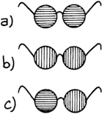

Which pair of glasses has the plane of polarization in the best orientation for reducing road glare while driving?

- Which of these lamps is emitting electromagnetic radiation?

- Lamp A
- Lamp B
- Both
- Neither
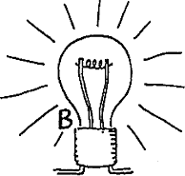
- REVIEW: Suppose at a concert a singer's voice is radio broadcast all the way around the world before reaching the radio you hold to your ear. This takes 1/8th of a second.

If you're close, you hear her voice in air before you hear it from the radio. But if you are far enough away, both signals will reach you at the same time.

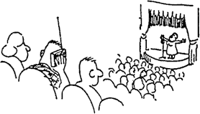

How many meters distant must you be for this to occur?
- Is it correct to say that in every case, without exception, any radio wave travels faster than any sound wave? Explain.

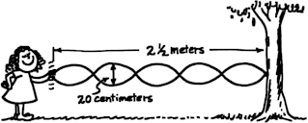
REVIEW:

  - In the standing wave shown above, what is the amplitude?

  - In the standing wave shown, what is its wavelength?

  - In the standing wave shown, how many nodes are there?

- Waves rock a boat in the middle of a pond. The boat moves up and down 10 times in 20 s. What is the period of the waves?

A. 0.5 s | B. 2 s | C. 10 s | D. 20 s

- Sunscreen protects skin by absorbing harmful ultraviolet radiation from the Sun. Ultraviolet radiation has which of the following properties?

A. a shorter wavelength than x-rays
B. a lower frequency than radio waves
C. a higher frequency than visible light
D. a longer wavelength than microwaves
- Which of the following is a difference between electromagnetic waves and mechanical waves?

A. Electromagnetic waves transmit energy, and mechanical waves transmit information.
B. Electromagnetic waves are always longitudinal, and mechanical waves are always transverse.
C. Electromagnetic waves can travel through a vacuum, and mechanical waves require a medium.
D. Electromagnetic waves have only low frequencies, and mechanical waves have only high frequencies.
- Grains and spices are irradiated with gamma rays to kill most of the bacteria or fungi that are normally present. Although microwaves are another form of radiation, the properties of these waves do not make them as useful as gamma rays for sterilizing food. In which of the following ways do gamma rays differ from microwaves?

A. Gamma rays have a lower frequency and longer wavelength than microwaves.
B. Gamma rays have a lower frequency and shorter wavelength than microwaves.
C. Gamma rays have a higher frequency and longer wavelength than microwaves.
D. Gamma rays have a higher frequency and shorter wavelength than microwaves.

